**GIS410: Intro to Remote Sensing**

**Lab 6: Deliverables**

**Due: Thursday, April 8th at 11:59 PM**

**Submit to Blackboard a single PDF document that includes:**

1. Four Tables (20 points)
2. The answers to the Lab 6 questions below (70 points)
3. Submitted images (10 points)

**TABLES**

1. Accuracy assessment table (Step 3 # 7)

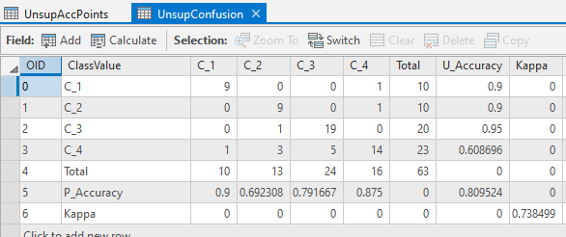

2. Pixel count, Area and Percent change tables (Step 4 #12)

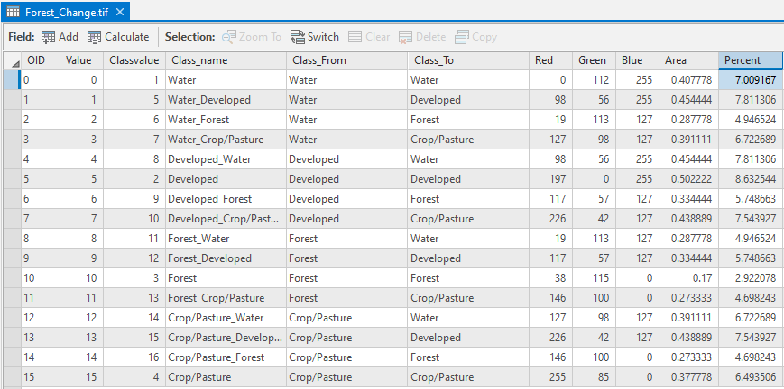

**QUESTIONS**

Q1: Why is it important to use a Stratified Random Sample scheme to identify the accuracy assessment points? (Hint: it may be useful to look at the ArcGIS Pro help on this tool to better understand the stratified random sampling scheme. If you hover to the left of different parts of the tool, an “i” icon will appear and if you hover that, more information for the tool will be provided. ) (10 points)

**The other options for sampling are random and equalized stratified random. Random creates points that are randomly distributed throughout the image, with this sampling it is possible, while not likely, that all of the points could be within one class or that a class will not have any points in it. Equalized stratified random creates points that are randomly distributed within each class, where each class has the same number of points. In our image this would not work well as there is a wide variation in the percent of the image covered by each land cover type, water only covers roughly 2-5 percent of the image so why should it have the same number of points as developed which covered roughly 30 percent of the image. With stratified random we still have randomized points within each class but the number of points in each class is proportional to its area.**

Q2: What might have happened if you used a “Random” sampling technique in terms of representation of the accuracy assessment points across the 4 different LULC types? (10 points)

**If we used a random sampling technique the accuracy of all 4 LULC types would likely decrease. It is unlikely that water will be well classified as it makes up such a small percentage of the land cover that it will likely not have a point within it. Cropland/Pasture would also likely be classified incorrectly as it goes across many different colors and value for the pixels, making it unlikely that each of these values will have point placed within them.**

Q3: Which LULC class had the highest Producers accuracy? Which had the lowest Producers accuracy? What does this tell you about the accuracy assessment in terms of these classes? Does this confirm what you found in Lab 5 when looking at the spectral response curves? Explain your answer. (10 points)

**C_1 has the highest producer accuracy. C-2 has the lowest producer’s accuracy. This tells us that developed lands have the highest counts of false negatives, where pixels of a known class are classified as something other than that class. This makes sense when compared to the spectral response curves from Lab 05. In this spectral profile water is very distinct from the other classes, where developed, forest, and cropland are all clustered much closer.**

Q4: Which LULC class had the highest Users accuracy? Which had the lowest Users accuracy? What does this tell you about the accuracy assessment in terms of these classes? (10 points)

**C_3 has the highest user accuracy. C_4 has the lowest Users accuracy. This tells us that there Cropland/Pastures has the most false positive identifications, meaning the pixels were incorrectly classified as a known class when they should have been classified as something else. It conversely tells us that Forests contained the least amount of false positive identifications.**

Q5: By percentage, which was the largest change combination (ie Cropland to Urban). Which was the smallest? What might be driving the largest change combination?(10 points)

**Forest to Crop/Pasture was the smallest percentage change combination. Developed to Water/Water to Developed was the largest. It could be possible that better imaging equipment allowed for better differentiation between the river and the developed area, as they have little physical separation between them.**

Q6: Why might it be useful to look at both the amount of change by area and the percent change for each class? (10 points)

**For classes with very small total areas a small change in area will have a large impact on the percent change. The opposite is also true, a class with a very large total area will have could have a small percent change that encompasses a very large area. By looking at both the change in total area and the percent change we are able to get a better sense of the true magnitude of the change.**

Q7: Compare this deforestation map to the 2003 classification and original imagery and consider where the majority of change is occurring. What human processes in particular may be driving the deforestation shown in this image? (10 points)

**It appears that the heavily developed areas of the eastern part of the map are expanding outwards. This is likely due to a growing population of the city, which requires more housing. Due to the location of the city the only option for expansion is to the west where there is a larger concentration of the forest land cover type.**

**IMAGES TO INCLUDE**

Step 5 #11. Image chip of the deforestation image. (10 points)

